Zoom Intro Meeting 8/18 Agenda

- Switching Perspective from
  - Speaker View (show guy photo)- point out buttons top right
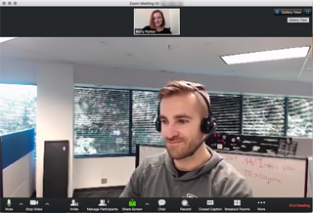

  - Speaker View for tablet (show gal photo) – point out buttons side left
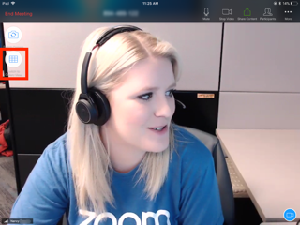
  - Gallery View (show photo)
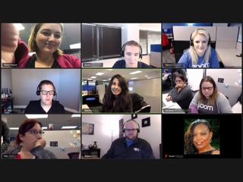
  - Gallery View for large group (Show photo)

- Control Buttons
  - Mute – unmute- using space bar – using thumbnail photo
  - Stop Video
  - Reactions
  - Leave Meeting (once you leave you cannot return)
  - Invite and Record buttons not needed
  - Participants
  - Chat
    - Using the chat to ask questions
    - Using the chat to speak to a particular friend

- Powerpoint

